A WEB GIS APPLICATION FOR INTEGRATION OF SOCIO-ECONOMIC, BIOPHYSICAL AND ATMOSPHERIC VARIABLES: A CASE STUDY OF PUNJAB PROVINCE



By

Syed Mustafa Haider Bokhari

Akram Ali Shah

Supervisor

Ms. Aneeqa Abrar

DR. Hammad Gillani

**Department of Space Science**

**Institute of Space Technology, Islamabad**

**September 2020**

A WEB GIS APPLICATION FOR INTEGRATION OF SOCIO-ECONOMIC, BIOPHYSICAL AND ATMOSPHERIC VARIABLES: A CASE STUDY OF PUNJAB PROVINCE

A thesis submitted to the

Institute of Space technology

In partial fulfillment of requirements

For the degree of Bachelor of Science in

Space Science

By

Syed Mustafa Haider Bokhari

Akram Ali Shah

Supervisor

Ms. Aneeqa Abrar

DR. Hammad Gillani

**Department of Space Science**

**Institute of Space Technology, Islamabad**

**September 2020**

Institute of Space Technology

Department of Space Science



A WEB GIS APPLICATION FOR INTEGRATION OF SOCIO-ECONOMIC, BIOPHYSICAL AND ATMOSPHERIC VARIABLES: A CASE STUDY OF PUNJAB PROVINCE

By

Syed Mustafa Haider Bokhari

Akram Ali Shah

APPROVAL BY BOARD OF EXAMINERS

-----------------------------------

Dr. Hammad Gillani

-----------------------------------

Ms. Aneeqa Abrar

**AUTHOR’S DECLERATION**

We take full responsibility of research work conducted during the FYP “A Web GIS application for integration of socio-economic, biophysical and atmospheric variables: A case Study of Punjab Province”. We solemnly declare that the research and development work presented in FYP is completely done by us with no significant help from any other person; however, small help wherever taken I duly acknowledged. We have also written the complete thesis by ourselves. Moreover, we have not presented this thesis (or substantially similar research and development work) or any part of thesis previously to any other degree awarding institution of Pakistan and abroad.

We understand that the management of IST has zero tolerance policy towards plagiarism. Therefore, we as author of above mentioned thesis declare that no portion of our thesis has been plagiarized and material used in the thesis used from the other sources is properly referenced. Moreover, the thesis does not contain any literal citing (verbatim) of more than 70 words (total) even by giving a reference in less we have obtained the written permission of publisher to do so. Furthermore, the work presented in the thesis is our own original work and we have positively cited the related work of the other researchers by clearly differentiating my work from their relevant work.

We further understand that if we found guilty of any plagiarism in our thesis work even after our graduation, the institute reserves the right to revoke our BS degree. Moreover, the institute will also have the right to publish our names on its website that keeps record of student who plagiarized in their thesis work.

-----------------------------

Syed Mustafa Haider Bokhari BS-SS-05 Reg. No. 160601009

----------------------------- Akram Ali Shah BS-SS-05 Reg. No. 160601023

-----------------------------

We here by acknowledge that submitted thesis is final version and should be scrutinized for plagiarism as per IST policy.

----------------------------- Dr. Hammad Gillani

----------------------------

MS. Aneeqa Abrar

Verified by Plagiarism Cell Officer Dated: -----------------

**CERTIFICATE**

This is to certify that the research work described in this thesis is the original work of the author(s) and has been carried out under our direct supervision. We have personally gone through all the data/results/materials reported in the manuscript and certify their correctness/authenticity. We further certify that the material included in this thesis is not plagerized and has not been used in part or full in a manuscript already submitted or in the process of submission in partial/complete fulfillment of the award of any other degree from any institution. We also certify that the thesis has been prepared under our supervision according to the prescribed format and I endorse its evaluation for the award of Bachelor of Sciences in Space science degree through the official procedures of the institute

----------------------------- Dr. Hammad Gillani

----------------------------

MS. Aneeqa Abrar

Copyright ©2020

This document is jointly copyright by the authors and Institute of Space Technology (IST). Both authors and IST can use, publish or reproduce this document in any form. Under the copyright law no part of this document can be reproduced by anyone, except copyright holders, without the permission of authors.

**ACKNOWLEDGMENT**

This Final year project would not have been possible without the blessings Of Allah almighty and his Prophet (S.A.W.W). Acknowledgement should also be given to our parents and family for supporting us throughout our bachelor’s degree. This project would not have been completed or possible without the guidance of our supervisors namely Dr Hammad Gillani and Miss Aneeqa Abrar.

**ABSTRACT**

As technology progresses the need for fast and efficient results also increases, this statement is true especially for decision makers as they require efficient results in order to make appropriate decisions. Traditionally desktop GIS was used to visualize data in the form of static maps, there were limitations associated with such a method such as one cannot manipulate the static map so you are bound to the information provided to you by the creator of the map hence they are not that efficient. On the other hand if data visualization was carried out on a web map which would result in dynamic mapping which allows one to manipulate it as they wish. Web GIS is the new platform for data visualization and display and in this project this platform is utilized to visualize time based data of Population, Precipitation, NDVI and Land surface temperature for the province Punjab of the country Pakistan. These variables are represented in their respective layers along with graphs which show the variation of said variables for their respective districts with time.

TABLE OF CONTENTS

**1** **INTRODUCTION** 1

**2** **LITERATURE REVIEW** 3

**2.1** **Web-GIS** 3

**2.1.1** **Architecture for WEB-GIS Application** 3

**2.1.2** **Bootstrap framework** 3

**2.2** **Thematic Maps** 4

**2.2.1** **Choropleth map** 4

**2.2.2** **Graduated Symbol Map** 4

**2.2.3** **Chart Symbol map** 4

**2.2.4** **Color varied symbol map** 5

**2.3** **Parameters** 5

**2.3.1** **Land Surface Temperature (LST)** 5

**2.3.2** **Population** 5

**2.3.3** **Precipitation** 6

**2.3.4** **Normalized Difference Vegetation Index** 6

**2.4** **Utilization of Web-GIS for Spatial Analysis** 6

**2.5** **Features utilized in other works** 7

**3** **METHODOLOGY** 10

**3.1** **Data Collection** 10

**3.1.1** **The Study area:** 10

**3.1.2** **Data Parameters and collection:** 13

**3.1.3** **Creation of Thematic Map in ArcMap:** 16

**4** **IMPLEMENTATION** 19

**4.1.1** **Creation of a Prototype Webpage/Web-GIS browser application:** 19

**4.1.2** **Work Flow Diagram for the creation of the web based geospatial portal** 20

**4.1.3** **Basic Elements of this Web based Geospatial portal** 21

**4.1.4** **Incorporation of Data into the webpage in order to create thematic map:** 22

**4.1.5** **Creation of Graphs:** 30

**5** **CONCLUSION** 34

**REFERENCES** 35

**LIST OF TABLES**

**Table No Table Caption Page No**

Table 2.1 Description of features 9

Table 4.1 Technologies and plugins utilized in the creation 20

Table 4.2 Basic elements of the portal 22

LIST OF FIGURES

**Figure No Figure Caption Page No**

Fig 2.1Table of features (1) 9

Fig 2.2 Table of features (2) 9

Fig 2.3 Table of features (3) 10

Fig 3.1 The Study area 13

Fig 3.2 NASA appEEARS 14

Fig 3.3 Flow diagram for creation of a thematic map 17

Fig 3.4 Punjab Thematic map with all Parameters 19

Fig 4.1 Work flow diagram for the portal 21

Fig 4.2 Initial Prototype webpage 22

Fig 4.3 Linking the GeoJson 24

Fig 4.4 Creating the choropleth layer for population density 24

Fig 4.5 Functions related with color/styling 25

Fig 4.6 Styling functions for NDVI layer 25

Fig 4.7 NDVI Choropleth layer on the portal26

Fig 4.8 Population Density Choropleth on the portal 26

Fig 4.9 Precipitation Choropleth on the portal27

Fig 4.10 Creating the graduated symbol layer for absolute population27

Fig 4.11 Graduated SVG symbol layer for absolute population …. 28

Fig 4.12 varying color symbol layer for NDVI 29

Fig 4.13 Varying Color Symbol Layer for NDVI on portal 30

Fig 4.14 Bar-chart creation 30

Fig 4.15 LST bar-chart layer 31

Fig 4.16 Creating the information control 32

Fig 4.17 The event function for information control 33

Fig 4.18 Creating the graphs through charts.js 34

Fig 4.19 The NDVI symbol layer with graph 34

# **INTRODUCTION**

Maps are wonderful not only do they tell you where to go but they also convey a story. In early times the maps were on papers but as time passed new technologies were discovered such as the computer and the internet, now maps were in the screens of the computers rather than pages. GIS (geographic information system) was a system developed to store, manipulate, analyze and manage spatial data. At one time Desktop GIS was the means for handling and representing spatial data but the trends have now shifted to Web based GIS which has several advantages such as accessibility, representation of spatial and non-spatial data in real time, sharing of data and it is easy to operate. This project named “A Web GIS application for integration of socio-economic, biophysical and atmospheric variables: A case study of Punjab province” aims to visualize Population density, Land Surface Temperature, Normalized Difference Vegetation Index and Precipitation data over the range of 2010-2019 of Punjab in the form of Thematic Maps on a geospatial web portal. A thematic map as the name implies is a map which represents a theme associated with a specific geographic area, in simpler terminology a thematic map represents the change of a variable over a geographic area. These Maps would visually inform the user the change in the above mentioned parameters over the years. The project would include graphs for graphical representation of the parameters. These graphs would represent in general the change of said parameters with time, these graphs would be included within the map as a “hover” interaction. The thematic layers used in this project for the parameters are as follows: Choropleth layer was used to visualize precipitation data, Choropleth layer and graduated symbols layer was used to visualize Population data, Choropleth layer and color symbols layer was used to visualize NDVI data, Charts symbol layer was used to visualize LST data. These parameters would provide information of socioeconomic, bio-physical along with atmospheric conditions of the Punjab province through visual analysis (thematic maps and graphs) of the parameters. Each of the parameters have their respective importance in planning projects, development projects and projects that involve data analysis such as for a case of construction or development it is essential to take into account the population data. Similarly for a case of agricultural planning it is important to take into account the Vegetation data

# **LITERATURE REVIEW**

## **Web-GIS**

Web GIS is a tool or a product of digital mapping that is based on internet network as its medium of communication. Functions of Web GIS as the communication media are to show, deploy, integrate, provide spatial and non-spatial information in various forms (such as digital maps, texts, diagrams), and run the main functions, namely analysis and queries which are still associated with GIS technology through internet network[1]. In simpler terminology Web GIS is the Geographic information system that uses the internet as a medium.

### **Architecture for WEB-GIS Application**

The basic architecture utilized in a Web GIS Application is the Client-Server type architecture, in which the client is the element that requests for data and data analysis while the server receives the request of the data from the client processes the said data and sends it back to the Client. The thin-client system architecture strives to minimize processing on the client; except for the presentation and user interaction, most of the data processing occurs at the server [2].For this project the simplest architecture or the thin-client architecture was utilized, the desktop web portal serves as the Client, a local web (HTTP) sever serves as the web server while a shapefile converted into a geojson file serves as the file server or simply the server.

### **Bootstrap framework**

It is one of the most well-known frameworks used for web development, it is used for website front end development. Generally it is used to make responsive projects in HTML, CSS and java script. It saves time in styling webpages and it also is used to create dynamic and responsive webpages.

## **Thematic Maps**

Thematic map is a map that focuses on a specific theme that are related to or connected to a geographic subject area. Thematic maps are composed of standard content elements such as mathematical elements, geographic elements, socioeconomic elements, and auxiliary and additional elements [3]. The basic example of themes that these maps deal with is temperature variation in an area. There are a lot of types of thematic maps for example choropleth maps, dot density maps, symbol maps, dot proportional maps.

### **Choropleth map**

Choropleth maps are commonly used to show statistical variation among map enumeration units, Choropleth maps show the variation in quantitative data among enumeration units such as countries, states, or counties [4]. These maps are generally used to show variation of data over a geographic extent, in simpler terms these maps represent the data visually over the polygon of the selected area.

### **Graduated Symbol Map**

Graduated symbol maps are the maps that have graduated symbols which are used to show the quantitative difference (through variation in size of said symbols) of the features that have been mapped. The data of the variable that is to be represented by graduated symbols is classified into classes based on certain classification techniques. In this project an SVG (Scalable Vector Graphics) was used as a graduated symbol, in simpler words a symbol representing population was used as a pictogram. Pictograms are particularly well suited when ‘catching’ the reader’s eye is a priority [5].

### **Chart Symbol map**

As the name implies, this kind of map uses charts in order to represent the data. Charts such as bar charts (line charts) and Pie charts are used to show the variation amongst certain variables. Bar-chart with scaled bars was used in this project to represent the variables of LST. Scaled bars yield more accurate results compared to area or volume symbols [4]. Each district of Punjab has their respective bar-chart.

### **Color varied symbol map**

It is simply a map that represents the variation amongst the data of a selected variable with a symbol which varies in color rather than size. The variation in color shows the variation in quantitative data among districts of Punjab (somewhat like a choropleth).

## **Parameters**

There are four data parameters in this project.

### **Land Surface Temperature (LST)**

Surface temperature is a universal, non-defined term describing combined temperature of intact objects present on land [6]. In simpler terms LST is the skin radiative temperature of a particular surface on the land (earth), LST is measured in the direction of the sensor mounted on the space craft. LST measures the emission of thermal radiance from the land surface where the incoming solar energy interacts with and heats the ground [7].The LST data provides us with good estimation of surface temperature of an area. The salient feature of LST is that it is a good indicator of energy at the surface to atmosphere boundary and that it is also sensitive to change conditions of the surface.

### **Population**

Population in general terms represents the number of people of an area. For this project the Population data was of two types the details of which are as follows:

#### **Absolute Population**

Absolute population is the population in absolute terms which means it refers to the number of people in a particular area. A good example of absolute population would be that of population census.

#### **Population Density**

Population density refers to the number of people per area. For the case of this project the population density was in the units of people per km^2. Population density can be represented in various thematic elements such as choropleth (used in this project) and dot density [8]

### **Precipitation**

Precipitation refers to the condensation of water vapors that fall to the ground due to gravity. Precipitation is an important atmospheric variable as agriculture, weather forecasting and water management require appropriate estimation of precipitation [9] and since Precipitation is highly variable in time and space satellite data are an important additional support. Precipitation data is utilized in various web based applications [9]

### **Normalized Difference Vegetation Index**

Use of remote sensing derived information in agriculture sector plays an important role for decision makers to know status of vegetation on larger spatial scale. Researchers have developed various indices for this purpose. Normalized Difference Vegetation Index (NDVI) is one such indices that measures vegetation vigor of crop [10]

## **Utilization of Web-GIS for Spatial Analysis**

Web-GIS has been used for spatial analysis in a lot of cases as it provides efficient, easy and interactive means for displaying spatial information. Generally spatial information is displayed on a Geospatial webpage or application through the utilization of JavaScript libraries such as Leaflet and Open Layers or through mapping servers like GeoServer. Geographic information can be displayed on the internet in a variety of forms. Thematic maps are a suitable medium for representing geographic information, said maps can be used to support decision makers and leaders regarding planning by creating solutions .Earthquake information can be displayed in a dynamic map browser type of web mapping applications [11]. Information Such as environmental pollution can be displayed and monitored through maps on a geospatial webpage [1]. Geospatial web portals can be used in the assessment of natural disasters like tsunamis [12].

## **Features utilized in other works**

The following table represents the important features (Web-GIS) in the various literature relating development of geospatial webpages and applications for spatial analysis. These features were taken in consideration during the webpage development process

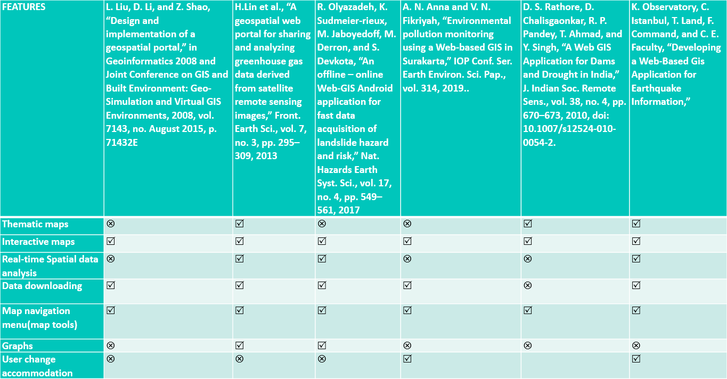

*Fig 2.1: Table of features (1)*

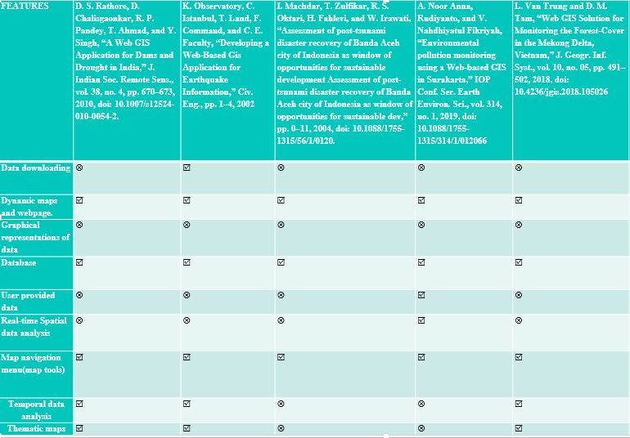

*Fig 2.2: Table of features (2)*

The following table represents the features used and not used in this project

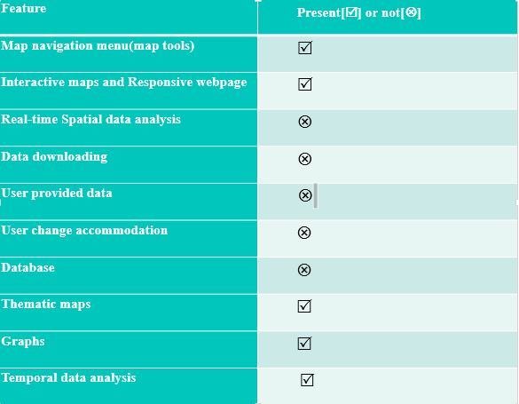

*Fig 2.3: Table of feature (3)*

The features are explained below

*Table 2.1:*

*Description of features*

|  |  |
| --- | --- |
| Feature Name | Description |
| Data downloading | Feature that allows the user of the geospatial web application or portal to download data from said portal or application |
| Dynamic maps and webpages/interactive maps | Feature that allows the user to interact with the map the user can zoom in and out of the map and the user can change the layer of the map.  simply the user can gain information through interacting with the map |
| Graphical representation of data | To represent the variation of data in variables through graphs |
| Database | Storing data |
| User provided data | Feature that allows the user to provide data to the WEB GIS application to work upon |
| Real-time Spatial data analysis | Feature that allows the user to manipulate data on his end through the Web GIS application |
| Map navigation menu (map tools) | Tools used to navigate through the map |
| Temporal data analysis | Analysis of the data that varies with time |
| Thematic maps | A thematic map as the name implies is a map which represents a theme associated with a specific geographic area. |
| User change/requirement accommodation | Feature that accommodates the users requirements |

# **METHODOLOGY**

## **Data Collection**

### **The Study area:**

The word Punjab literally means “five waters” which is referring to Jhelum, Chenab, Ravi, Beas, and Sutlej rivers, which are tributaries of the Indus River. Punjab is situated in the 31°N 72°E (latitude and longitude) coordinates. Punjab is one of the most important province of Pakistan. The total area covered by Punjab is 205,344 km2, its capital is the city of Lahore which is located in the east central region near the border with India. Punjab Is a land rich for agriculture purposes, however it has its share of issues. One of the said issues is Population, Punjab is already the most populated province of Pakistan with an estimated population of 110,012,442 approximately as of 2017 census. The increasing Population of Punjab is a serious problem which leads to economic consequences. Greater the population greater is the demand off goods such as food, etc. Hence for a country like Pakistan with limited industries, this means greater inflation (which results in various other problems). Population increase also causes an increase in the Pollution of the environment, the pollution to be noted is the pollution of air which greatly effects the life of the civilians. According to the 2015 findings of the medical journal Lancet, a whopping 22 percent of annual deaths in Pakistan are caused by pollution, and the majority of those are due to air pollution [13]. The main Gasses emitted into the air which cause pollution are No2 Co2 and O3.The increase in population also causes an increase in urbanization which causes an increase of urban zones. The most overbearing problem in urban zones is increase in the surface temperature. When vegetation areas are converted in constructed areas, it affects the surface temperature by maximum absorption of solar radiation [6], which increases the land surface temperature. An increase in temperature of an area overall can also effect the precipitation patterns of said area. The Map of the Study area is on the next page

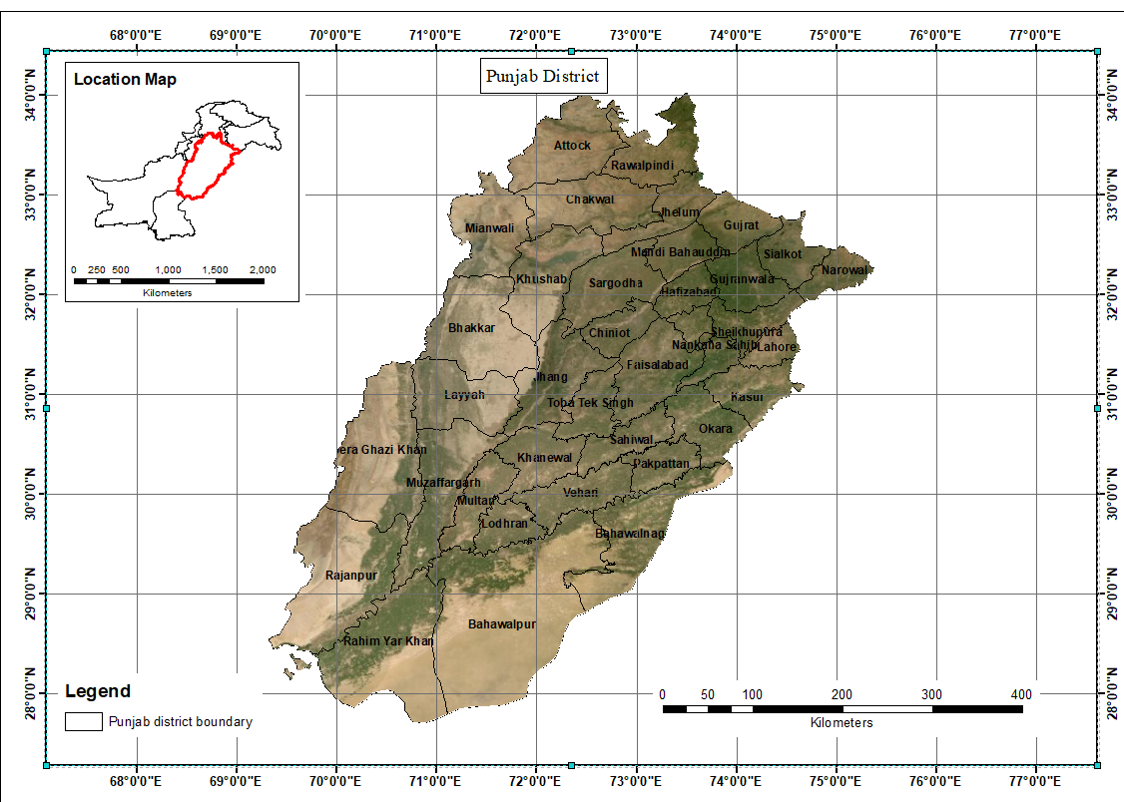

*Fig 3.1: The Study area*

### **Data Parameters and collection:**

The data parameters for this project are as follows:

1. Land Surface Temperature (LST)
2. Population (Both absolute and in density)
3. Precipitation
4. Normalized Difference Vegetation Index (NDVI)

The data for the first two parameters and that of Normalized difference vegetation index (NDVI) was collected through NASA appEEARS. NASA appEEARS (LP DAAC - AppEEARS, 2020) is a web based application for exploring and extracting various satellite data products along with their graphical representations.

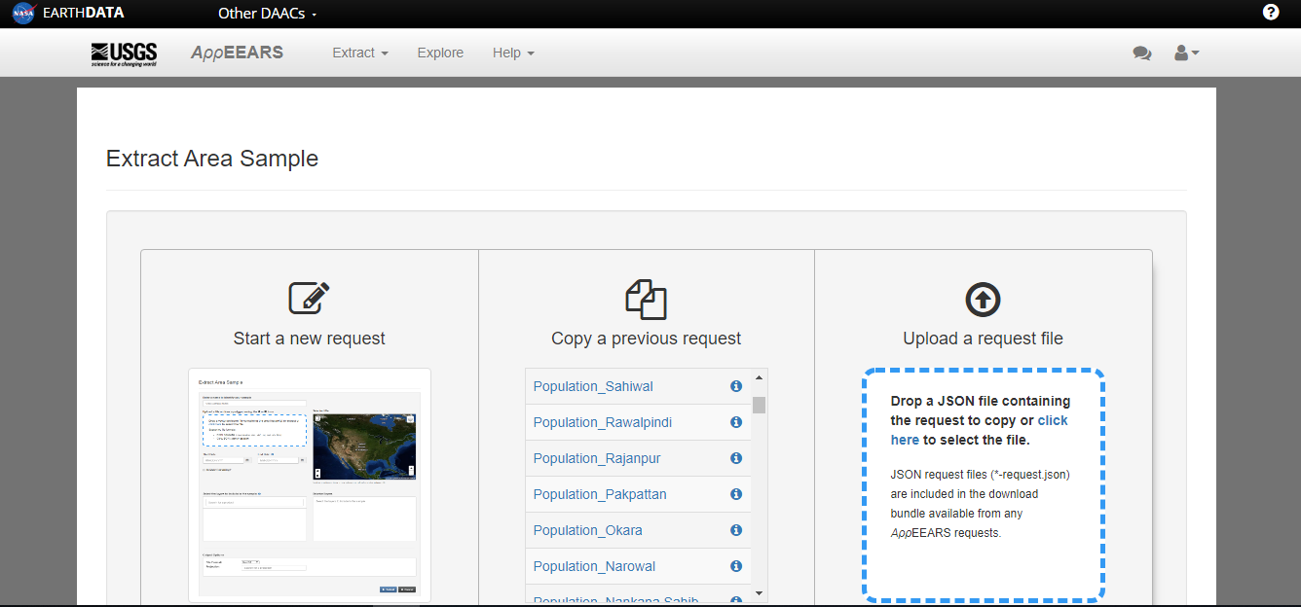

Fig 3.2: NASA appEEARS

Collection of data can be done through using anyone of the two methods provided, first is the “Point sample request” which is used for point data and the second is the “Area sample request” which is obviously used for requesting area sample. For Land Surface Temperature (LST) and Population density “Area sample request” was used. In this method after starting a new request you have to name the sample, select the area whose data is to be collected either by drawing bounding box in the map or by uploading the shapefile (heavy data can affect the download speed and can be sometimes restricted by the website), selection of appropriate satellite data product, setting up a temporal range (for Population) or seasonal range (for LST), selection of data format and coordinate system and the submission of said request. The data request takes some time (depending upon how big data is) and then it’s available in the explore panel where the visualization and downloading options are available.

The data products used for Land Surface Temperature (LST) were of the satellite MODIS (Moderate Resolution Imaging Spectroradiometer) Aqua (EOS PM) and Terra (EOS AM), a 16 days composite data for both day and night respectively. Since the data is to be represented/visualized on the geospatial web portal in time based thematic maps hence the time range for the data was from 2010 to 2019.For LST time range was seasonal (summer and winter with recurring range of 2010 to 2019), summer data consists of month June while the winter data consists of the month of December. The original units of the LST data was in kelvin which were converted into Celsius. Gridded Population of the World (GPW) product from NASA appEEARS was used to collect data for the population density the units of which were number of people persons per km2, which was also converted into absolute population. The available data products are yearly averaged of year 2010, 2015 and 2019.The values of year 2019 is forcasted data based on the trends of 2010, 2015 and censius data. This Population density data was also converted into absolute population by multiplying the density value of a district with the area of the district. The data product utilized for Normalized Difference Vegetation Index (NDVI) is “MOD13A3 MODIS/Terra vegetation Indices Monthly L3 Global 1km SIN Grid V006”. Normalized Difference Vegetation Index, is used to determine the state of plants' health. NDVI value of zero represents no green vegetation and values close to +1 (0.8 - 0.9) indicates the highest possible density of green leaves. The time range for the data was from 2010 to 2019. The data was originaly aqquired in monthly terms , this monthly data was converted to yearly data for each district to represent the variation of vegetation of each district on yearly basis.The data product of precipitation is TRMM 3B43: Monthly Precipitation Estimates, from Dataset Provider “NASA GES DISC at NASA Goddard Space Flight Center”. The data was downloaded using Google Earth Engine (GEE). This dataset algorithmically merges microwave data from multiple satellites, including SSMI, SSMIS, MHS, AMSU-B and AMSR-E, each of these are inter-calibrated to the TRMM Combined Instrument. The data was originally in “mm/hr” after it was converted to “mm/year’ for yearly representation. The data of all the parameters (LST, Population, Precipitation and Normalized Difference Vegetation Index (NDVI)) was collected in form of a CSV file which was “joined” to a shapefile which was converted into a geojson file. After successful collection of data it was refined and additional information such as max and min values were removed, mean values were calculated and used instead and monthly data was converted into yearly data. The refined data is then used for creating thematic maps.

### **Creation of Thematic Map in ArcMap:**

#### **Thematic Map creation Work Flow Diagram**

*Fig 3.3: Flow diagram for creation of a thematic map*

Initially the four parameters/variables were represented in a static thematic map through creation of a thematic map in Arc Map. In order to create a thematic map in ArcMap you need to have appropriate data, the variable that is varying should also be clearly defined

Before creating the thematic maps the shapefile must contain the appropriate data in this case it is the CSV data (obtained from appEEARS), this is done by the method called inner join in Arc Map. Through this inner join method the information in the CSV file can be exported into the attribute table of the shape file, this method is case sensitive.

#### **Creating a Choropleth thematic layer in Arc Map**

Creation of choropleth maps in Arc Map requires classification to be performed in. The classes were created on the basis of “natural break” which resulted in classes in float point values, which were refined and rounded off. Precipitation data was chosen to be represented by a choropleth layer.

#### **Creating a Graduated Symbol layer in Arc Map**

Symbols that vary with size with respect to the classes assigned to them are graduated symbols, the classes were created on the basis of “natural breaks”. Absolute Population was chosen to be represented by graduated symbols.

#### **Creating a Chart layer in Arc map**

Bar charts were chosen to represent the four variables of the LST (Land Surface temperature) parameter as it clearly visualizes the variation amongst said variables. The variables in LST were: Summer-Night, Summer-Day, Winter Night and Day temperature.

#### **Creating a varying color Symbol layer in Arc Map**

The basic concept behind such a layer is a symbol (be it a circle or any kind of symbol) that varies in color similar to a choropleth. In order to create such a layer in Arc Map we just need to change the symbol being associated to a layer and use the classes created by “natural breaks” in order to vary the color amongst the circle

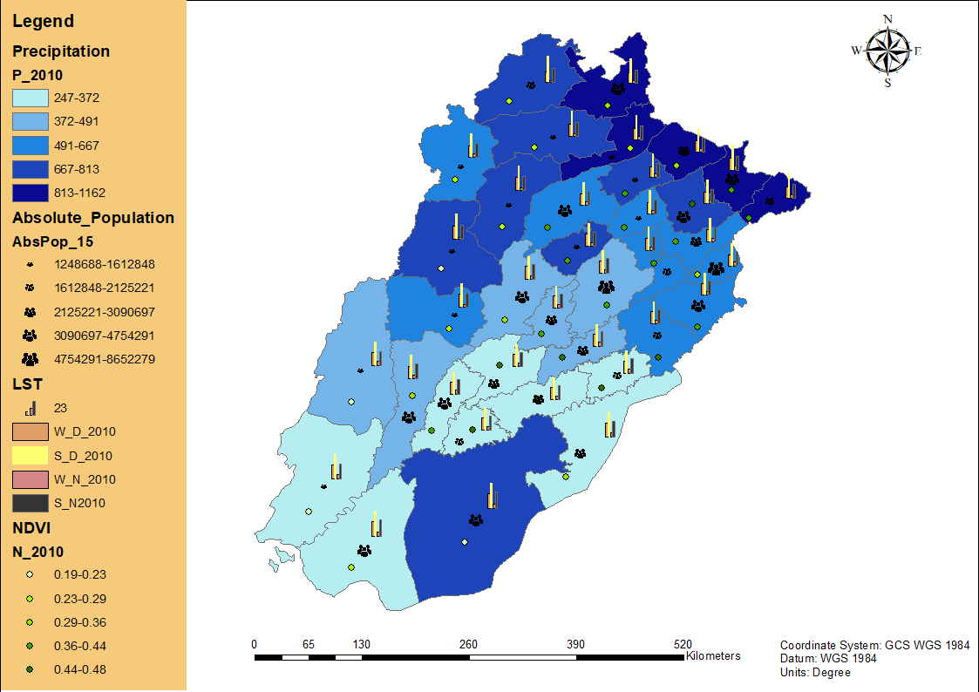

*Fig 3.4: Punjab Thematic map with all Parameters*

# **IMPLEMENTATION**

### **Creation of a Prototype Webpage/Web-GIS browser application:**

There are a lot of methods, libraries (JavaScript), software and mapping services to create a Web-GIS browser application such as Map server, OpenLayer, ArcMap Online and Leaflet. In this Project the following things were utilized to create a Geospatial web portal

Table 4.1:

Technologies and plugins utilized in the creation of prototype webpage

|  |  |
| --- | --- |
| Html And CSS | In order to create and style the webpage front |
| Bootstrap | To make a dynamic and responsive web-page |
| Leaflet | To enable mapping on the webpage |
| JavaScript along with jQuery | To introduce specific functionalities in the webpage and map and to link the mapping element with other element in the GUI |
| GeoJson files | Used for storing the data of the parameters of the districts of Punjab Province of Pakistan. The GeoJson file was used in order to create the thematic map layers on the web page |
| Charts.js | A JavaScript library that is used to create/generate graphs. The Time varying graphs were created through this library |
| Data Visualization Framework | A Leaflet plugin which was used to create the Charts (bar-charts) for the LST (Land Surface Temperature) Parameter |
| Geocoding | A geocoding plugin of leaflet was used in order to allow the user to search for his/her district and zoom to the center of said district |
| Time Slider | A Time slider as used in order to allow the user to switch between the layers |
| Full screen plugin | A leaflet plugin utilized to display the map on the entire screen of the device being used to view the map |
| Zoom-home plugin | A leaflet plugin used to zoom to a specific location when clicked |

### **Work Flow Diagram for the creation of the web based geospatial portal**

*Fig 4.1: Work flow diagram for the portal*

The Prototype Created was initially (before the incorporation of data) as follows

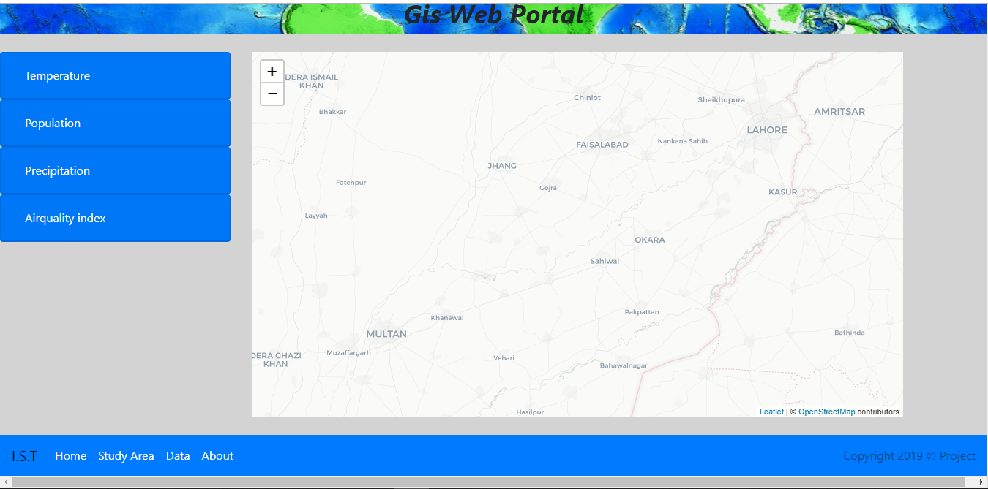

*Fig 4.2: Initial Prototype webpage*

### **Basic Elements of this Web based Geospatial portal**

The elements included in the GUI of the geospatial web portal are as follows

Table 4.2:

Basic elements of the portal

|  |  |
| --- | --- |
| Element | Description and Use |
| Accordion | An element that includes the check boxes which have to be clicked in order to show layers on the map element |
| Navigation bar (bottom) | It includes clickable links to additional web pages. It basically allows a user to navigate in this portal |
| Home page (On the Navigation Bar) | The page shown in fig 4.6 is the home page |
| Study area (On the Navigation Bar) | A page which shows basic information about the study area which is Punjab province of Pakistan in this case |
| Map element | This includes the map and all the thematic layers |
| About (On the Navigation Bar) | A page which shows basic information about the geospatial web portal along with the team involved in the creation of said portal |
| Graphs | Used to represent the time varying data. Graphs are included in an info control on the map element which is activated when the user hovers over a district |

### **Incorporation of Data into the webpage in order to create thematic map:**

#### **Creating Choropleth layer for Population density, Precipitation and NDVI for the portal**

For the creation of the Choropleth map of population density of Punjab and the NDVI the Shapefile joined with the downloaded CSV was converted into a GeoJson file which was linked to HTML through the code



*Fig 4.3: Linking the GeoJson*

A variable “**final**” was assigned to the GeoJson file, through which it was operated upon by JavaScript. The Population density, NDVI and Precipitation data was fetched from said GeoJson file and three Choropleth layers were created for three years (namely 2010, 2015 and 2020). A function was used in order to bring about the color with respect to the changing values.

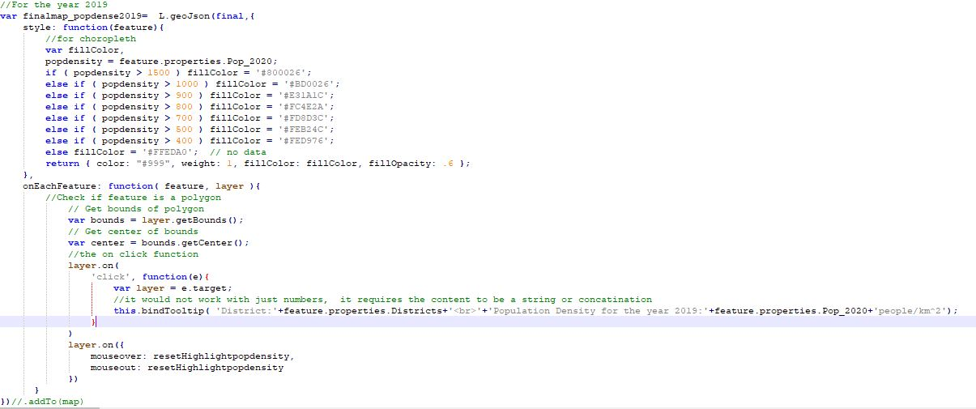

*Fig 4.4: Creating the choropleth layer for population density*

The variable named “popdensity” had the population density values within it and colors were being assigned depending upon said values and the district polygons were being styled depending upon the colors

The following functions were used to bring about the colors corresponding to the population density values.

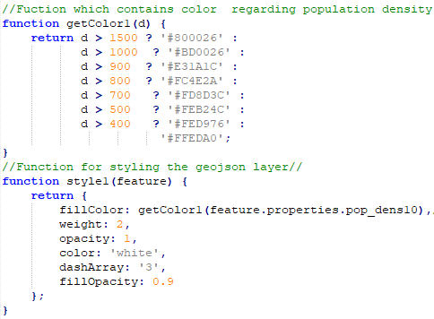

*Fig 4.5: Functions related with color/styling*

For the NDVI parameter the Choropleth was created similarly to that of population density with a slight difference of function used to generate the colors depending upon the data. The functions used and the Code for the layer is as follows

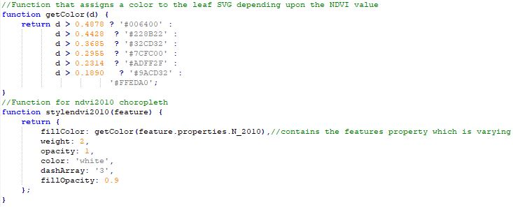

*Fig 4.6: Styling functions for NDVI layer*

The Precipitation Parameter choropleth was created similar to the choropleth of NDVI and Population density

The Choropleth layer for population density, NDVI and precipitation are as follows.

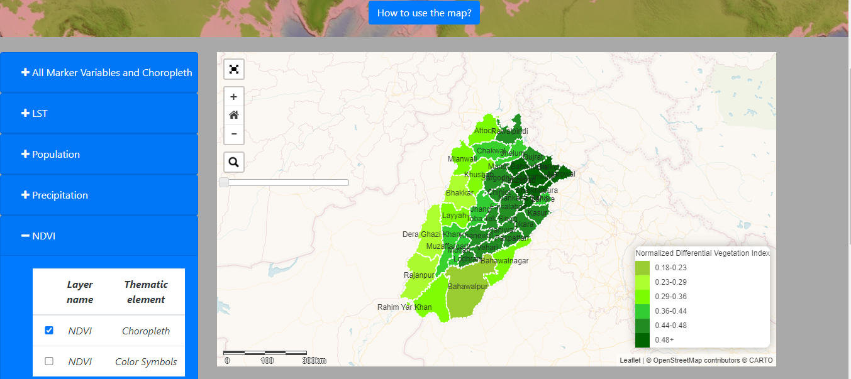

*Fig 4.7: NDVI Choropleth layer on the portal*

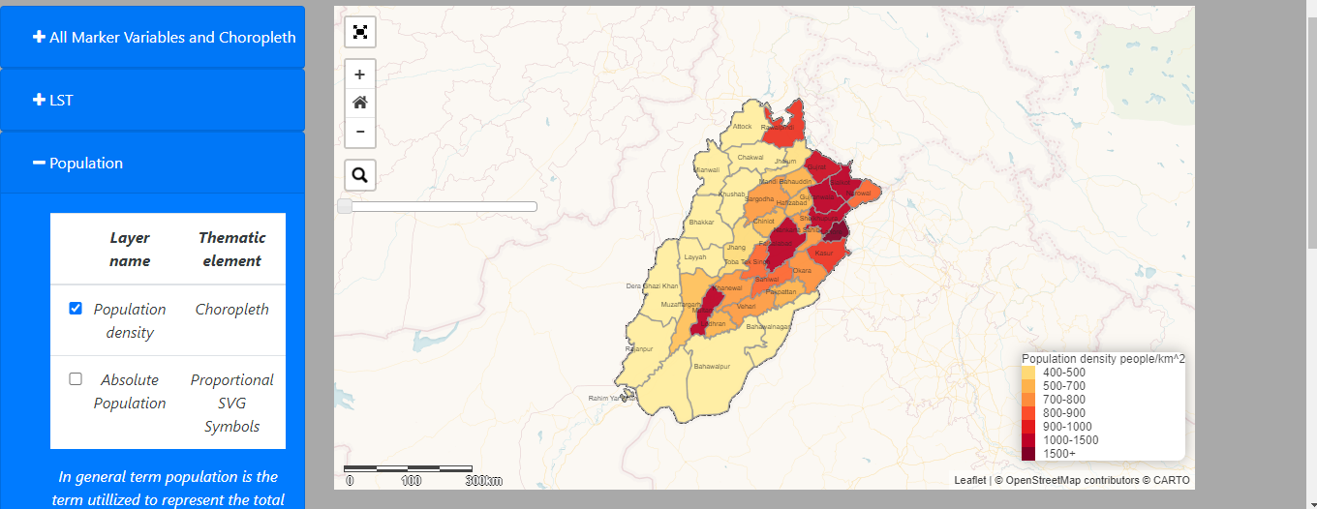

*Figure 4.8: Population Density Choropleth on the portal*

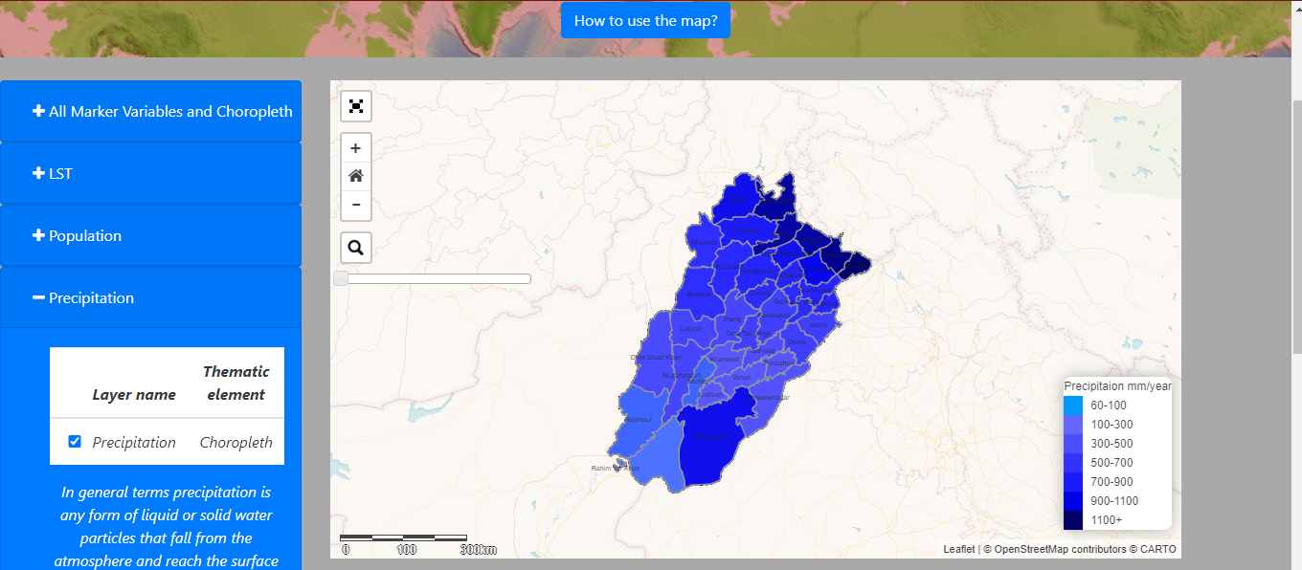

*Fig 4.9: Precipitation Choropleth on the portal*

#### **Creating the Graduated Symbol Layer for the Absolute Population**

The Absolute population data which was calculated from the population density data was represented by a graduated symbol layer, in which the symbol was an SVG (Scalable Vector Graphics) icon that was used to represent the data. A function named “abspop2010” was used in order to assign sizes to the SVG icons with respect to the data values of absolute population. The function used is as follows:

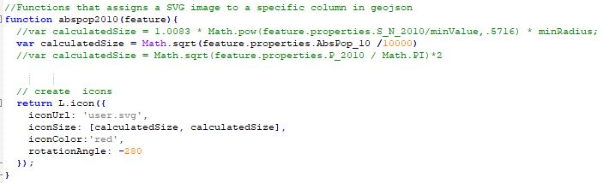

*Fig 4.10: Creating the graduated symbol layer for absolute population*

The variable “calculateSize” contains the formula used to assign sizes to the SVG icons.

The Resulting Layer on the webpage is as follows.

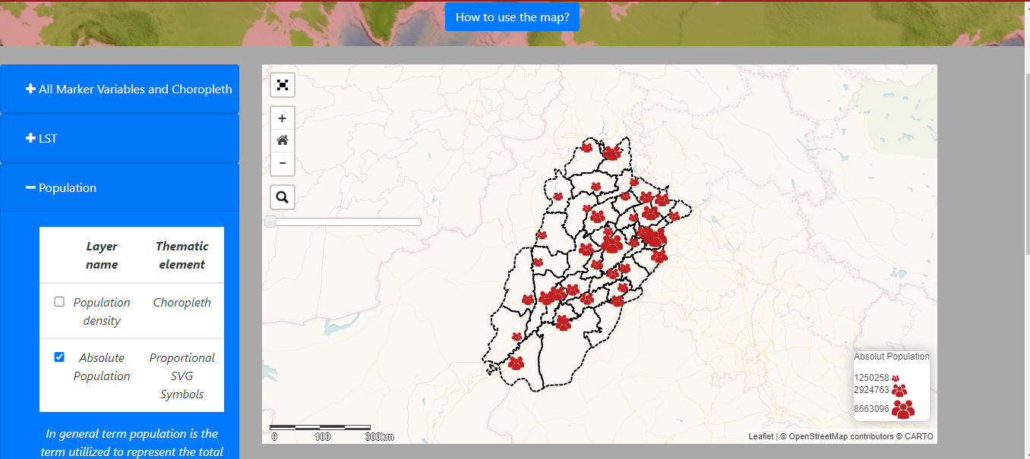

*Fig 4.11: Graduated SVG symbol layer for absolute population on the portal*

#### **Creating the varying color symbol layer for NDVI**

The symbol used in this case was also a SVG icon. The functions in figure 4.10 were used to generate colors with respect to the values of NDVI. These colors were assigned to the SVG icons associated with their respective districts. The “L.divIcon” was used in order to fetch the SVG and change its style.

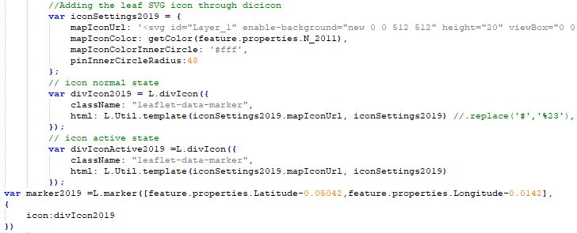

*Figure 4.12 varying color symbol layer for NDVI*

The resulting layer on the portal is as follows

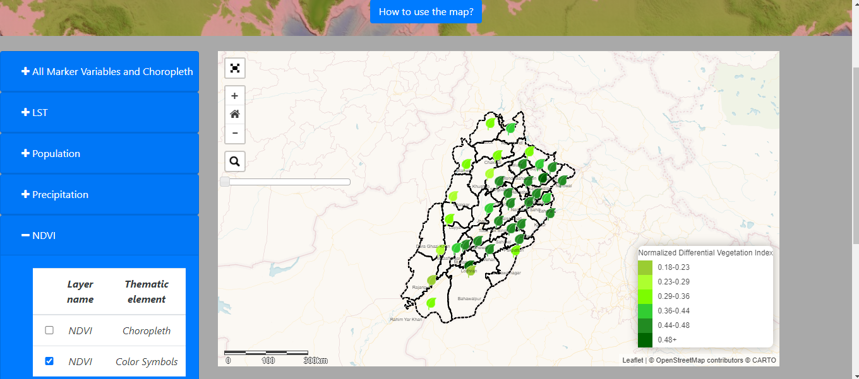

*Fig 4.13: Varying Color Symbol Layer for NDVI on portal*

#### **Creating the Chart layer for LST on the portal**

“Data visualization framework” a leaflet plugin was used to create the chart that represent the four variables of the LST parameter. Plugins have their own specific formats and syntaxes that are required to be followed if one wants to perform something. This plugin also has its own format in order to create the bar-chart, basically first thing to do is to fetch the data from GeoJson file and store it in a variable then define the number of bars in the bar chart and specify which bar represents what variable of the LST parameter then style the bars accordingly. The Code used to create said bar-charts is as follows:

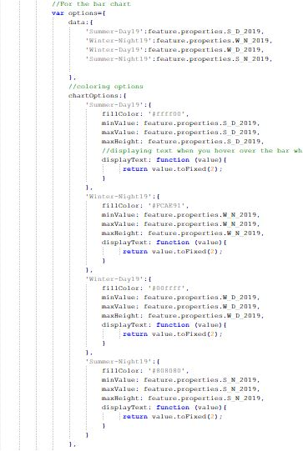

*Fig 4.14: Bar-chart creation*

The resulting layer is as follows:

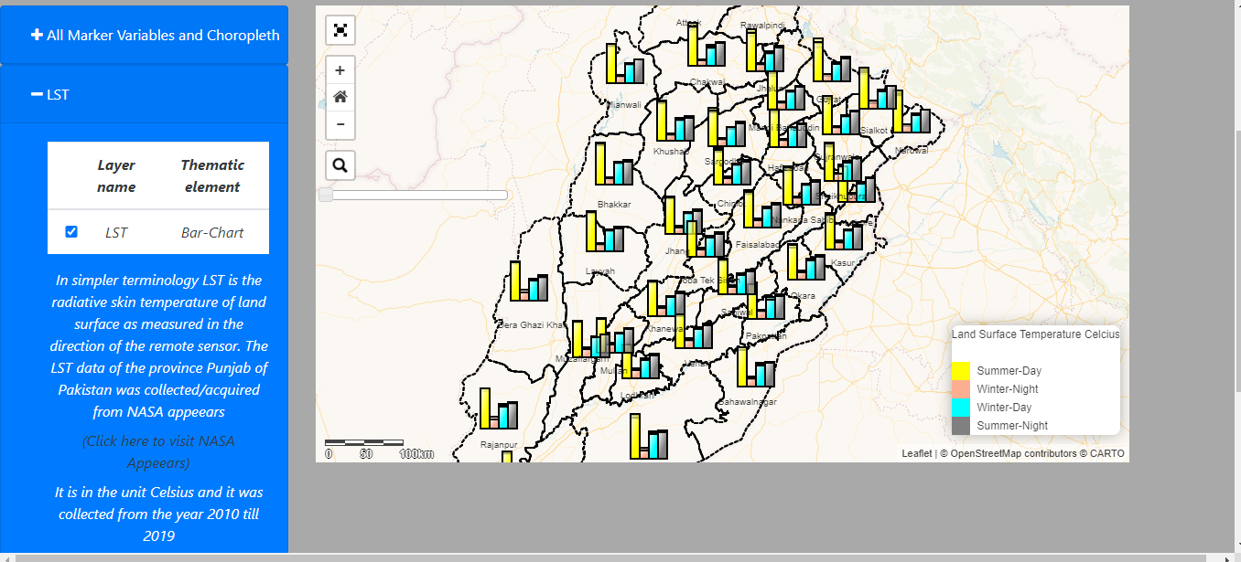

*Fig 4.15: LST bar-chart layer*

### **Creation of Graphs:**

In order to create the time varying graphs which represent the change of the parameters overtime “Charts.js” JavaScript library was used. All of the graphs are line graphs where the time value is on the X-axis and the parameter data values are on the Y-axis. The charts were represented in the “information control” of Leaflet on the top right position on the map element on the webpage. The creation of the graphs are as follows:

#### **Creating an information control**

First you have to create an information control which can be created by using “L.control()” and then creating a div element which can be manipulated through DOMs (Document object Model) through using html. You also define the labels and data in the “labelsndvic” and “datandvic” variables

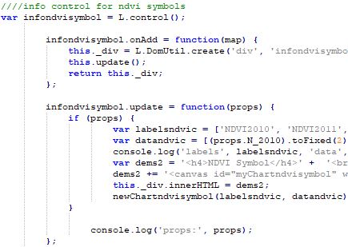

*Fig 4.16: Creating the information control*

Event functions also have to be created in order to impose a specific style on the polygon of the district and generate a graph on the information control through hovering over each district.

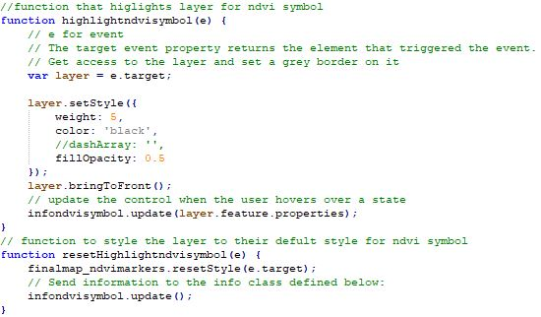

*Fig 4.17: The event function for information control*

#### **Creating the Charts**

First you need to create a function that takes the data and labels defined when you were creating the information control and uses them to generate graphs on the information control the function created for the NDVI symbol layer is “newChartndvisymbol”

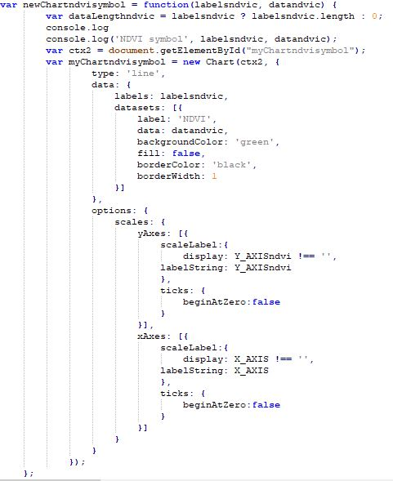

*Fig 4.18: Creating the graphs through charts.js*

Then you create a variable (for this case the variable is ctx2) to fetch the chart element through DOM and then this variable along with the fetched element is used to create a graph using the syntax provided by Charts.js in which you define the initials like the data for the graph, the type of graph and define the scales. The resulting graph is as follows

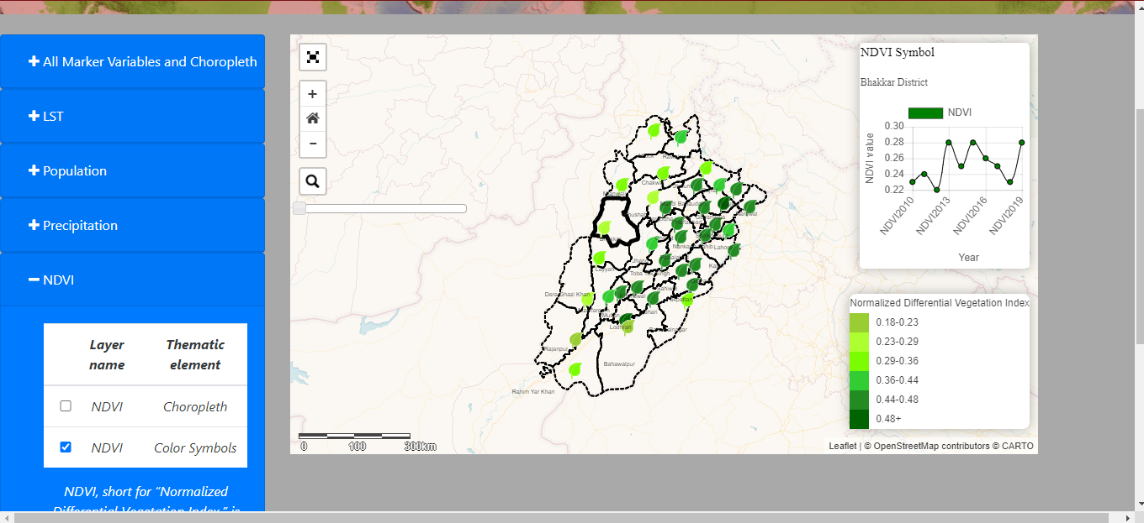

*Fig 4.19: The NDVI symbol layer with graph*

# **CONCLUSION**

For a decision making organization like disaster management or planning/development organization data is to be visualized without delay for timely decisions. There are web pages that provide data and data analysis quite quickly like NASA appEEARS however even for websites like NASA appears it takes a day or more for large areas like for example data for the whole province Punjab of Pakistan could not be taken as the selected area was too large for processing. Hence the basic idea and objective behind this project was a geospatial web portal that facilitates data analysis and data visualization on click! Such that for a planning and development organization looking to build a market sector or something else can look at the population and vegetation data from this geospatial web portal and plan accordingly.

This geospatial web portal can also be used for research purposes as it represents four temporal parameters visually and graphically. Hence for researchers researching the temporal variation of NDVI, LST, Population and Precipitation this geospatial web portal can be a good source for research. This geospatial web portal can further be created into a decision support system .The basic result of this project is a geospatial web portal that facilitates data analysis and data visualization both through thematic maps and through graphical representation. As already mentioned/ discussed in chapter 3 this geospatial web portal can be used for industrial purposes where data visualization is required “On click basis”, basically this geospatial web portal would be a good tool for decision making organizations (like disaster management , urban planning and resource management organizations) it could also be used to facilitate research. This project also has the scope to be converted into a Decision support system as well.

# **REFERENCES**

[1] A. Noor Anna, Rudiyanto, and V. Nahdhiyatul Fikriyah, “Environmental pollution monitoring using a Web-based GIS in Surakarta,” *IOP Conf. Ser. Earth Environ. Sci.*, vol. 314, no. 1, 2019, doi: 10.1088/1755-1315/314/1/012066.

[2] P. S. Singh, D. Chutia, and S. Sudhakar, “Development of a Web Based GIS Application for Spatial Natural Resources Information System Using Effective Open Source Software and Standards,” *J. Geogr. Inf. Syst.*, vol. 04, no. 03, pp. 261–266, 2012, doi: 10.4236/jgis.2012.43031.

[3] V. Kovarik and V. Talhofer, “General procedure of thematic map production using GIS technology,” *Int. Conf. Mil. Technol. Proceeding, ICMT*, no. January, pp. 1401–1408, 2013.

[4] J. Stewart and P. J. Kennelly, “Illuminated choropleth maps,” *Ann. Assoc. Am. Geogr.*, vol. 100, no. 3, pp. 513–534, 2010, doi: 10.1080/00045608.2010.485449.

[5] C. Brewer and A. J. Campbell, “Beyond Graduated Circles: Varied Point Symbols for Representing Quantitative Data on Maps,” *Cartogr. Perspect.*, no. 29, pp. 6–25, 1998, doi: 10.14714/cp29.672.

[6] A. Liaqut, “Impact of Urbanization Growth on Land Surface Temperature using remote,” *Int. J. Econ. Environ.*, vol. 9, no. January, pp. 44–49, 2018.

[7] Y. Yu and P. Yu, “Land Surface Temperature Product from the GOES-R Series,” *GOES- R Ser. A New Gener. Geostationary Environ. Satell.*, pp. 133–144, 2019, doi: 10.1016/B978-0-12-814327-8.00012-3.

[8] E. Gomes, “Creating a Dot Density Map: Resident Population in Mainland Portugal,” *Cartogr. J.*, vol. 54, no. 2, pp. 157–162, 2017, doi: 10.1080/00087041.2016.1148106.

[9] I. Dyras and D. Serafin-Rek, “The application of GIS technology for precipitation mapping,” *Meteorol. Appl.*, vol. 12, no. 1, pp. 69–75, 2005, doi: 10.1017/S135048270400146X.

[10] U. K. Gupta, “Forecasting and visualization of NDVI series using statistical methods through Web-GIS Forecasting and visualization of NDVI series using statistical methods through Web-GIS,” no. October 2019, 2020.

[11] K. Observatory, C. Istanbul, T. Land, F. Command, and C. E. Faculty, “Developing a Web-Based Gis Application for Earthquake Information,” *Civ. Eng.*, pp. 1–4, 2002.

[12] I. Machdar, T. Zulfikar, R. S. Oktari, H. Fahlevi, and W. Irawati, “Assessment of post-tsunami disaster recovery of Banda Aceh city of Indonesia as window of opportunities for sustainable development Assessment of post-tsunami disaster recovery of Banda Aceh city of Indonesia as window of opportunities for sustainable dev,” pp. 0–11, 2004, doi: 10.1088/1755-1315/56/1/0120.

[13] Shaikh, S. and Tunio, S., 2018. *Pakistan Moves to Curb Urban Air Pollution after High Court Ruling*. [Online] U.S. Available at: <https://www.reuters.com/article/us-pakistan-airpollution-court/pakistan-moves-to-curb-urban-air-pollution-after-high-court-ruling-idUSKBN1I11B5>.